**Homework 11**

**NULL functions**

**1.**select name,start_date,NVL2(end_date,'end in two weeks',sysdate)

AS "REPLACED END DATE"

from f_promotional_menus;

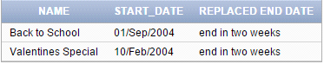

**2.** select last_name,NVL(overtime_rate,0)"Overtime Status"

from f_staffs;

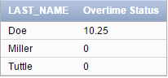

**3.**select last_name,to_char(NVL2(overtime_rate,'$5.00','$5.00')) AS "Substitute"

from f_staffs;

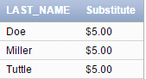

**4.**select last_name,NVL(manager_id,'9999')

from f_staffs;

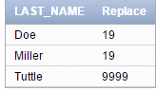

**5. C**

**6.** SELECT COALESCE(last_name, to_char(manager_id)) as NAME

FROM f_staffs;



if employees dont have last name, replace manager_id with "NAME"

**7. PART 1** SELECT first_name,last_name,hire_date

FROM employees;

**PART 2** select first_name,last_name,NULLIF(to_char(hire_date,'MM'),'09')

from employees;

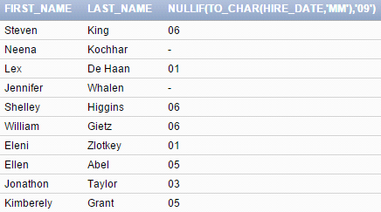

**8.** select first_name,NVL(specialty,'No Specialty.') AS "Specialty"

from d_partners;

